2. Loading the Dataset
Code:
mydata <- read.csv("Cars93.csv", header = TRUE, sep = ",")
str(mydata)
print(summary(mydata))
print(dim(mydata))
output for this
> mydata <- read.csv("Cars93.csv", header = TRUE, sep = ",")
> str(mydata)
'data.frame': 93 obs. of 28 variables:
$ rownames : int 1 2 3 4 5 6 7 8 9 10 ...
$ Manufacturer : chr "Acura" "Acura" "Audi" "Audi" ...
$ Model : chr "Integra" "Legend" "90" "100" ...
$ Type : chr "Small" "Midsize" "Compact" "Midsize" ...
$ Min.Price : num 12.9 29.2 25.9 30.8 23.7 14.2 19.9 22.6 26.3 33 ...
$ Price : num 15.9 33.9 29.1 37.7 30 15.7 20.8 23.7 26.3 34.7 ...
$ Max.Price : num 18.8 38.7 32.3 44.6 36.2 17.3 21.7 24.9 26.3 36.3 ...
$ MPG.city : int 25 18 20 19 22 22 19 16 19 16 ...
$ MPG.highway : int 31 25 26 26 30 31 28 25 27 25 ...
$ AirBags : chr "None" "Driver & Passenger" "Driver only" "Driver & Passenger" ...
$ DriveTrain : chr "Front" "Front" "Front" "Front" ...
$ Cylinders : chr "4" "6" "6" "6" ...
$ EngineSize : num 1.8 3.2 2.8 2.8 3.5 2.2 3.8 5.7 3.8 4.9 ...
$ Horsepower : int 140 200 172 172 208 110 170 180 170 200 ...
$ RPM : int 6300 5500 5500 5500 5700 5200 4800 4000 4800 4100 ...
$ Rev.per.mile : int 2890 2335 2280 2535 2545 2565 1570 1320 1690 1510 ...
$ Man.trans.avail : chr "Yes" "Yes" "Yes" "Yes" ...
$ Fuel.tank.capacity: num 13.2 18 16.9 21.1 21.1 16.4 18 23 18.8 18 ...
$ Passengers : int 5 5 5 6 4 6 6 6 5 6 ...
$ Length : int 177 195 180 193 186 189 200 216 198 206 ...
$ Wheelbase : int 102 115 102 106 109 105 111 116 108 114 ...
$ Width : int 68 71 67 70 69 69 74 78 73 73 ...
$ Turn.circle : int 37 38 37 37 39 41 42 45 41 43 ...
$ Rear.seat.room : num 26.5 30 28 31 27 28 30.5 30.5 26.5 35 ...
$ Luggage.room : int 11 15 14 17 13 16 17 21 14 18 ...
$ Weight : int 2705 3560 3375 3405 3640 2880 3470 4105 3495 3620 ...
$ Origin : chr "non-USA" "non-USA" "non-USA" "non-USA" ...
$ Make : chr "Acura Integra" "Acura Legend" "Audi 90" "Audi 100" ...
> print(summary(mydata))
rownames Manufacturer Model
Min. : 1 Length :93 Length :93
1st Qu.:24 N.unique :32 N.unique :93
Median :47 N.blank : 0 N.blank : 0
Mean :47 Min.nchar: 3 Min.nchar: 2
3rd Qu.:70 Max.nchar:13 Max.nchar:14
Max. :93

Type Min.Price Price
Length :93 Min. : 6.70 Min. : 7.40
N.unique : 6 1st Qu.:10.80 1st Qu.:12.20
N.blank : 0 Median :14.70 Median :17.70
Min.nchar: 3 Mean :17.13 Mean :19.51
Max.nchar: 7 3rd Qu.:20.30 3rd Qu.:23.30
Max. :45.40 Max. :61.90

Max.Price MPG.city MPG.highway
Min. : 7.9 Min. :15.00 Min. :20.00
1st Qu.:14.7 1st Qu.:18.00 1st Qu.:26.00
Median :19.6 Median :21.00 Median :28.00
Mean :21.9 Mean :22.37 Mean :29.09
3rd Qu.:25.3 3rd Qu.:25.00 3rd Qu.:31.00
Max. :80.0 Max. :46.00 Max. :50.00

AirBags DriveTrain Cylinders
Length :93 Length :93 Length :93
N.unique : 3 N.unique : 3 N.unique : 6
N.blank : 0 N.blank : 0 N.blank : 0
Min.nchar: 4 Min.nchar: 3 Min.nchar: 1
Max.nchar:18 Max.nchar: 5 Max.nchar: 6

EngineSize Horsepower RPM
Min. :1.000 Min. : 55.0 Min. :3800
1st Qu.:1.800 1st Qu.:103.0 1st Qu.:4800
Median :2.400 Median :140.0 Median :5200
Mean :2.668 Mean :143.8 Mean :5281
3rd Qu.:3.300 3rd Qu.:170.0 3rd Qu.:5750
Max. :5.700 Max. :300.0 Max. :6500

Rev.per.mile Man.trans.avail Fuel.tank.capacity
Min. :1320 Length :93 Min. : 9.20
1st Qu.:1985 N.unique : 2 1st Qu.:14.50
Median :2340 N.blank : 0 Median :16.40
Mean :2332 Min.nchar: 2 Mean :16.66
3rd Qu.:2565 Max.nchar: 3 3rd Qu.:18.80
Max. :3755 Max. :27.00

Passengers Length Wheelbase
Min. :2.000 Min. :141.0 Min. : 90.0
1st Qu.:4.000 1st Qu.:174.0 1st Qu.: 98.0
Median :5.000 Median :183.0 Median :103.0
Mean :5.086 Mean :183.2 Mean :103.9
3rd Qu.:6.000 3rd Qu.:192.0 3rd Qu.:110.0
Max. :8.000 Max. :219.0 Max. :119.0

Width Turn.circle Rear.seat.room
Min. :60.00 Min. :32.00 Min. :19.00
1st Qu.:67.00 1st Qu.:37.00 1st Qu.:26.00
Median :69.00 Median :39.00 Median :27.50
Mean :69.38 Mean :38.96 Mean :27.83
3rd Qu.:72.00 3rd Qu.:41.00 3rd Qu.:30.00
Max. :78.00 Max. :45.00 Max. :36.00
NAs :2
Luggage.room Weight Origin
Min. : 6.00 Min. :1695 Length :93
1st Qu.:12.00 1st Qu.:2620 N.unique : 2
Median :14.00 Median :3040 N.blank : 0
Mean :13.89 Mean :3073 Min.nchar: 3
3rd Qu.:15.00 3rd Qu.:3525 Max.nchar: 7
Max. :22.00 Max. :4105
NAs :11
Make
Length :93
N.unique :93
N.blank : 0
Min.nchar: 7
Max.nchar:24

> print(dim(mydata))
[1] 93 28

3. Data Type Conversion
Code:
mydata$Type <- factor(mydata$Type)
mydata$AirBags <- factor(mydata$AirBags)
mydata$DriveTrain <- factor(mydata$DriveTrain)
mydata$Origin <- factor(mydata$Origin)
print(colSums(is.na(mydata)))
Output of this code

> mydata$Type <- factor(mydata$Type)
> mydata$AirBags <- factor(mydata$AirBags)
> mydata$DriveTrain <- factor(mydata$DriveTrain)
> mydata$Origin <- factor(mydata$Origin)
>
> print(colSums(is.na(mydata)))
rownames Manufacturer
0 0
Model Type
0 0
Min.Price Price
0 0
Max.Price MPG.city
0 0
MPG.highway AirBags
0 0
DriveTrain Cylinders
0 0
EngineSize Horsepower
0 0
RPM Rev.per.mile
0 0
Man.trans.avail Fuel.tank.capacity
0 0
Passengers Length
0 0
Wheelbase Width
0 0
Turn.circle Rear.seat.room
0 2
Luggage.room Weight
11 0
Origin Make
0 0

4. Missing Value Handling
Code - Introducing missing values:

set.seed(123)
na_rows_1 <- sample(1:nrow(mydata), 8)
mydata$Horsepower[na_rows_1] <- NA
na_rows_2 <- sample(1:nrow(mydata), 6)
mydata$AirBags[na_rows_2] <- NA

print(colSums(is.na(mydata)))
print(which(is.na(mydata$Horsepower)))
print(which(is.na(mydata$AirBags)))
output of the code
> print(which(is.na(mydata$Horsepower)))
[1] 14 31 42 43 50 51 67 79
> print(which(is.na(mydata$AirBags)))
[1] 9 14 25 57 69 90

Code - Method (i): Discard Instances:
data_removed <- na.omit(mydata)
print(dim(mydata))
print(dim(data_removed))

output of the code
> data_removed <- na.omit(mydata)
> print(dim(mydata))
[1] 93 28
> print(dim(data_removed))
[1] 70 28
Code - Method (ii): Replace by Average / Most Frequent Value:
mean_hp <- mean(mydata$Horsepower, na.rm = TRUE)
mydata$Horsepower <- ifelse(is.na(mydata$Horsepower), mean_hp, mydata$Horsepower)

air_table <- table(mydata$AirBags)
air_mode <- names(air_table)[which.max(air_table)]
mydata$AirBags[is.na(mydata$AirBags)] <- air_mode
mydata$AirBags <- factor(mydata$AirBags)

print(colSums(is.na(mydata)))
output of the code
> mean_hp <- mean(mydata$Horsepower, na.rm = TRUE)
> mydata$Horsepower <- ifelse(is.na(mydata$Horsepower), mean_hp, mydata$Horsepower)
>
> air_table <- table(mydata$AirBags)
> air_mode <- names(air_table)[which.max(air_table)]
> mydata$AirBags[is.na(mydata$AirBags)] <- air_mode
> mydata$AirBags <- factor(mydata$AirBags)
>
> print(colSums(is.na(mydata)))
rownames Manufacturer
0 0
Model Type
0 0
Min.Price Price
0 0
Max.Price MPG.city
0 0
MPG.highway AirBags
0 0
DriveTrain Cylinders
0 0
EngineSize Horsepower
0 0
RPM Rev.per.mile
0 0
Man.trans.avail Fuel.tank.capacity
0 0
Passengers Length
0 0
Wheelbase Width
0 0
Turn.circle Rear.seat.room
0 2
Luggage.room Weight
11 0
Origin Make
0 0

7. Data Normalization and Transformation
Code - Min-Max Normalization:
price_min <- min(mydata$Price)
price_max <- max(mydata$Price)
mydata$Price.norm <- (mydata$Price - price_min) / (price_max - price_min)
print(summary(mydata$Price.norm))

hp_min <- min(mydata$Horsepower)
hp_max <- max(mydata$Horsepower)
mydata$Horsepower.norm <- (mydata$Horsepower - hp_min) / (hp_max - hp_min)
output of the code is
> price_min <- min(mydata$Price)
> price_max <- max(mydata$Price)
> mydata$Price.norm <- (mydata$Price - price_min) / (price_max - price_min)
> print(summary(mydata$Price.norm))
Min. 1st Qu. Median Mean 3rd Qu. Max.
0.00000 0.09358 0.20183 0.22200 0.28073 1.00000
>
> hp_min <- min(mydata$Horsepower)
> hp_max <- max(mydata$Horsepower)
> mydata$Horsepower.norm <- (mydata$Horsepower - hp_min) / (hp_max - hp_min)
Code - Log Transformation:

mydata$Price.log <- log(mydata$Price)
print(summary(mydata$Price.log))

output of the code is
> mydata$Price.log <- log(mydata$Price)
> print(summary(mydata$Price.log))
Min. 1st Qu. Median Mean 3rd Qu. Max.
2.001 2.526 2.912 2.867 3.122 4.126

9. Descriptive Statistics (with Plots)

print(summary(mydata))
print(sd(mydata$Price))
print(sd(mydata$Horsepower))
print(mean(mydata$Price))
print(median(mydata$Price))
print(var(mydata$Price))

hist(mydata$Price, main = "Histogram of Price", xlab = "Price")
hist(mydata$MPG.city, main = "Histogram of MPG City", xlab = "MPG City")
barplot(table(mydata$Type), main = "Car Type Distribution")
plot(mydata$Horsepower, mydata$Price, main = "Price vs Horsepower")
output of the code

print(summary(mydata))
rownames Manufacturer Model
Min. : 1 Length :93 Length :93
1st Qu.:24 N.unique :32 N.unique :93
Median :47 N.blank : 0 N.blank : 0
Mean :47 Min.nchar: 3 Min.nchar: 2
3rd Qu.:70 Max.nchar:13 Max.nchar:14
Max. :93

Type Min.Price Price
Compact:16 Min. : 6.70 Min. : 7.4
Large :11 1st Qu.:10.80 1st Qu.:12.5
Midsize:21 Median :14.70 Median :18.4
Small :23 Mean :17.13 Mean :19.5
Sporty :14 3rd Qu.:20.30 3rd Qu.:22.7
Van : 8 Max. :45.40 Max. :61.9

Max.Price MPG.city MPG.highway
Min. : 7.9 Min. :15.00 Min. :20.00
1st Qu.:14.7 1st Qu.:18.00 1st Qu.:26.00
Median :19.6 Median :21.00 Median :28.00
Mean :21.9 Mean :22.37 Mean :29.09
3rd Qu.:25.3 3rd Qu.:25.00 3rd Qu.:31.00
Max. :80.0 Max. :46.00 Max. :50.00

AirBags DriveTrain Cylinders
Driver & Passenger:15 4WD :10 Length :93
Driver only :45 Front:67 N.unique : 6
None :33 Rear :16 N.blank : 0
Min.nchar: 1
Max.nchar: 6

EngineSize Horsepower RPM
Min. :1.000 Min. : 55.0 Min. :3800
1st Qu.:1.800 1st Qu.:110.0 1st Qu.:4800
Median :2.400 Median :142.0 Median :5200
Mean :2.668 Mean :144.5 Mean :5281
3rd Qu.:3.300 3rd Qu.:170.0 3rd Qu.:5750
Max. :5.700 Max. :300.0 Max. :6500

Rev.per.mile Man.trans.avail Fuel.tank.capacity
Min. :1320 Length :93 Min. : 9.20
1st Qu.:1985 N.unique : 2 1st Qu.:14.50
Median :2340 N.blank : 0 Median :16.40
Mean :2332 Min.nchar: 2 Mean :16.66
3rd Qu.:2565 Max.nchar: 3 3rd Qu.:18.80
Max. :3755 Max. :27.00

Passengers Length Wheelbase
Min. :2.000 Min. :141.0 Min. : 90.0
1st Qu.:4.000 1st Qu.:174.0 1st Qu.: 98.0
Median :5.000 Median :183.0 Median :103.0
Mean :5.086 Mean :183.2 Mean :103.9
3rd Qu.:6.000 3rd Qu.:192.0 3rd Qu.:110.0
Max. :8.000 Max. :219.0 Max. :119.0

Width Turn.circle Rear.seat.room
Min. :60.00 Min. :32.00 Min. :19.00
1st Qu.:67.00 1st Qu.:37.00 1st Qu.:26.00
Median :69.00 Median :39.00 Median :27.50
Mean :69.38 Mean :38.96 Mean :27.83
3rd Qu.:72.00 3rd Qu.:41.00 3rd Qu.:30.00
Max. :78.00 Max. :45.00 Max. :36.00
NAs :2
Luggage.room Weight Origin
Min. : 6.00 Min. :1695 non-USA:45
1st Qu.:12.00 1st Qu.:2620 USA :48
Median :14.00 Median :3040
Mean :13.89 Mean :3073
3rd Qu.:15.00 3rd Qu.:3525
Max. :22.00 Max. :4105
NAs :11
Make Price.norm Horsepower.norm
Length :93 Min. :0.00000 Min. :0.0000
N.unique :93 1st Qu.:0.09358 1st Qu.:0.2245
N.blank : 0 Median :0.20183 Median :0.3551
Min.nchar: 7 Mean :0.22200 Mean :0.3652
Max.nchar:24 3rd Qu.:0.28073 3rd Qu.:0.4694
Max. :1.00000 Max. :1.0000

Price.log
Min. :2.001
1st Qu.:2.526
Median :2.912
Mean :2.867
3rd Qu.:3.122
Max. :4.126

> print(sd(mydata$Price))
[1] 9.586863
> print(sd(mydata$Horsepower))
[1] 50.34611
> print(mean(mydata$Price))
[1] 19.49892
> print(median(mydata$Price))
[1] 18.4
> print(var(mydata$Price))
[1] 91.90793
>
> hist(mydata$Price, main = "Histogram of Price", xlab = "Price")
> hist(mydata$MPG.city, main = "Histogram of MPG City", xlab = "MPG City")
> barplot(table(mydata$Type), main = "Car Type Distribution")
> plot(mydata$Horsepower, mydata$Price, main = "Price vs Horsepower")
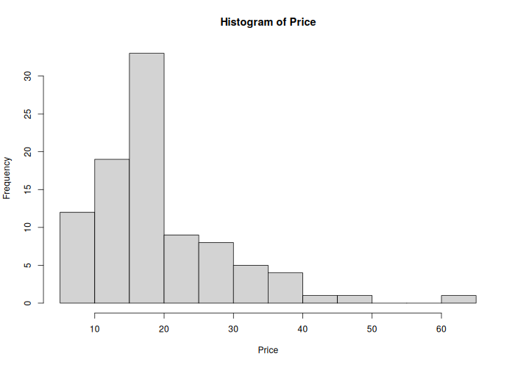
Figure 5 — Histogram: "Histogram of Price"
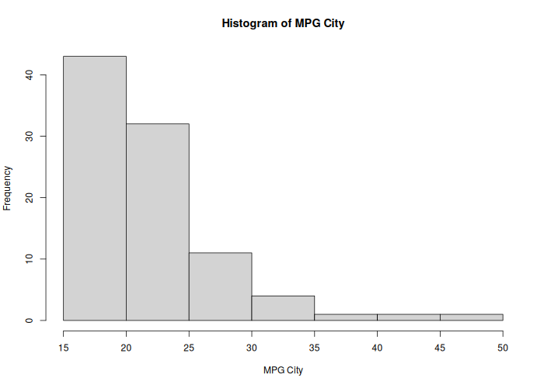

Figure 6 — Histogram: "Histogram of MPG City"
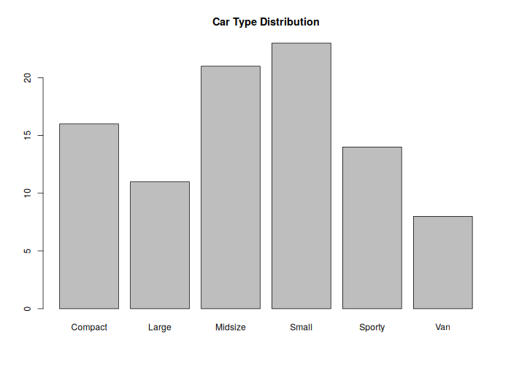
Figure 7 — Bar plot: "Car Type Distribution"
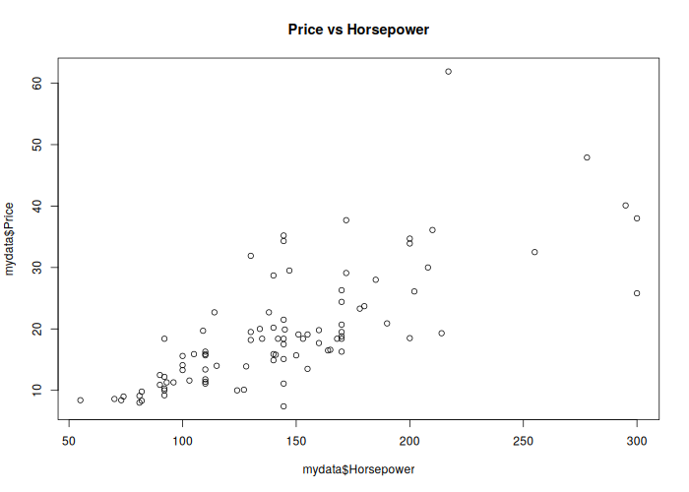
Figure 8 — Scatter plot: "Price vs Horsepower"
11. Feature Selection

print(cor(mydata$Price, mydata$Horsepower))
print(cor(mydata$Price, mydata$Weight))
print(cor(mydata$Price, mydata$MPG.city))
print(cor(mydata$Price, mydata$EngineSize))

model <- lm(Price ~ Horsepower + Weight + EngineSize, data = train_data)
print(summary(model))
output of the code is

> print(cor(mydata$Price, mydata$Horsepower))
[1] 0.7421584
> print(cor(mydata$Price, mydata$Weight))
[1] 0.63469
> print(cor(mydata$Price, mydata$MPG.city))
[1] -0.5673545
> print(cor(mydata$Price, mydata$EngineSize))
[1] 0.5893542
>
> model <- lm(Price ~ Horsepower + Weight + EngineSize, data = train_data)
> print(summary(model))

Call:
lm(formula = Price ~ Horsepower + Weight + EngineSize, data = train_data)

Residuals:
Min 1Q Median 3Q Max
-11.0329 -4.0359 -0.5163 1.6466 30.1911

Coefficients:
Estimate Std. Error t value Pr(>|t|)
(Intercept) -12.726999 4.732603 -2.689 0.00895 **
Horsepower 0.143652 0.023407 6.137 4.48e-08 ***
Weight 0.005988 0.002419 2.475 0.01574 *
EngineSize -2.451742 1.413062 -1.735 0.08713 .
---
Signif. codes:
0 ‘***’ 0.001 ‘**’ 0.01 ‘*’ 0.05 ‘.’ 0.1 ‘ ’ 1

Residual standard error: 6.437 on 70 degrees of freedom
Multiple R-squared: 0.5952, Adjusted R-squared: 0.5778
F-statistic: 34.3 on 3 and 70 DF, p-value: 9.439e-14

